# VALIDATION DOCUMENT

Validating software involves recording evidence that proves a software system meets the proper specifications and quality attributes; that it’s been installed correctly; and that it will fulfill its intended use.

Verification: Are we building the product right?  
Validation: Are we building the right product?

Not to the client

1. PROJECT INFORMATION
   1. Project Name
   2. Date of document submission
   3. Version of document (if any changes)
   4. Client (name of client company)

Also state which team member is responsible for writing which section in this document.

1. PROJECT TEAM

Describe how the project will be organized and managed. Identify reporting lines and outline specific roles that will be filled. You need to be clear about staff roles so that you don't duplicate responsibilities, and so that everyone is clear about what's expected of them. If this is a long-term project, you may even consider developing job descriptions for team members.

|  |  |  |
| --- | --- | --- |
| Team Member | Role | Document Responsibilities |
|  |  |  |
|  |  |  |
|  |  |  |
|  |  |  |

1. PROJECT SCOPE AND DEFINITION

Outline the strategic vision, goals & objectives and ideally include a high-level mission statement. This will help align the team on the approach and keep these goals in mind during solutioning. It will also help in defining additional work and potential project enhancements as the team keep this context in mind.

1. TERMS AND DEFINITIONS
2. REVISION HISTORY

Describe (list) how the scope and design changed from the original PID and each successive increment (as a timeline). Indicate any design changes recommended by the client.

Use from retrospectives and whatnot

|  |  |
| --- | --- |
| Sprint | Changes in scope, design, or programming. |
| 0-1 | How each sprint may have morphed successively for each increment. |

1. USE CASE

Describe the step-by-step (“walkthrough”, “workflow”) usability (user) process from input(s) to output(s). (Refer to UML Use Case)

Walk through the use case diagram (do not insert the diagram)

|  |  |  |  |  |
| --- | --- | --- | --- | --- |
| Step | Use Case | Test Steps | Test Data | Expected Result |
| 1 | User login: Verify Login | 1. Go to login page  2. Enter User ID  3. Enter PW  4. Click login | Id=XYZ123  PW=1234 | Login successful |

1. VALIDATION TESTING (REQUIREMENT TRACEABILITY)

IQ/OQ/PQ Framework

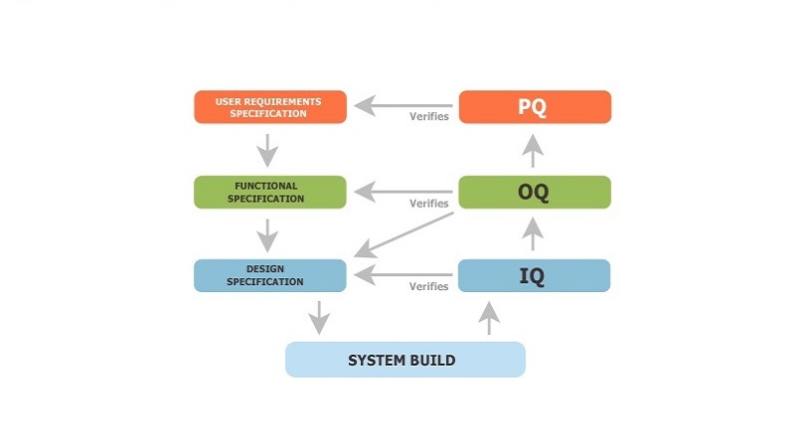

IQ (installation qualification). OQ (operational qualification). PQ (performance qualification).

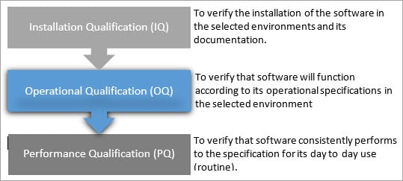

|  |  |  |
| --- | --- | --- |
| Requirement Validation (Refer to Requirements Document) | Metrics Indicate requirement(s) and how each will be tested, checked, and/or measured. Sometimes referred to as a Test Case) | Action Items  (Remediation if metrics or testing not met.) |
| System and OS Environments IQ | Access to secure web server | N/A |
| Hardware Requirements IQ | Any device that supports a browser | N/A |
| Software Requirements IQ | Web browser | N/A |
| Installation and Configuration IQ | Web files uploaded to appropriate folders | 1. Check web/folder structure an organization 2. Review syntax |
| Network Requirements IQ/OQ |  |  |
| Code Testing and Documentation OQ | 1. Code commenting 2. Code peer review 3. Unit testing: How do you know the function/module does what it’s supposed to do? 4. Integration testing: How do you know modules work together? 5. Error handling: How does your code handle (possible) errors? | 1. Meaningful comments 2. Team code review 3. Question answers here |
| Key User Operations OQ | Developer inputs  Simulation, creation |  |
| Data Management OQ | Internet |  |
| Database OQ | Xml |  |
| Data Inputs (All inputs that the software product will receive. Includes specification of ranges, limits, de-faults, response to illegal inputs. OQ | xml |  |
| Data Outputs (All outputs that the software product will produce. Includes data formats, screen presenta- tions, storage medium, printouts, generation of documents) OQ |  |  |
| Interface and Usability Testing PQ | OQ |  |  |
| Performance/Responsiveness PQ |  |  |
| Error Checking Management PQ | How does your system handle user error? |  |
| Peer Testing Procedures PQ | As a team, see if there’s anything that’s not working |  |
| Client Review and Procedures PQ | How will you demonstrate the product to the client? (abstract/synopsis/overview of product, poster, user manual, etc.) |  |